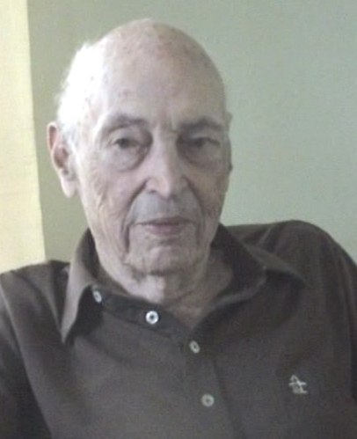
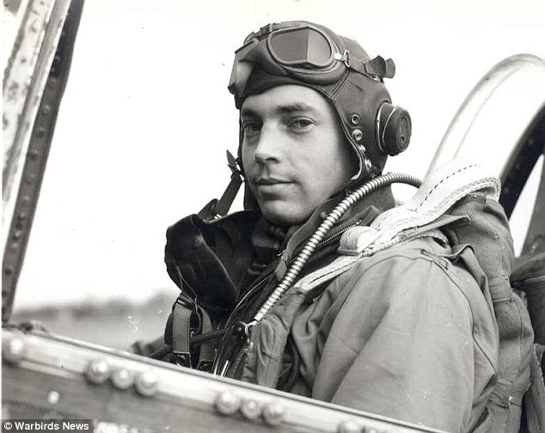
BILL OVERSTREET
AMERICAN PILOT
&
WAR VETERAN

EARLY HELP TOWARDS RIGOROUS TRAINING
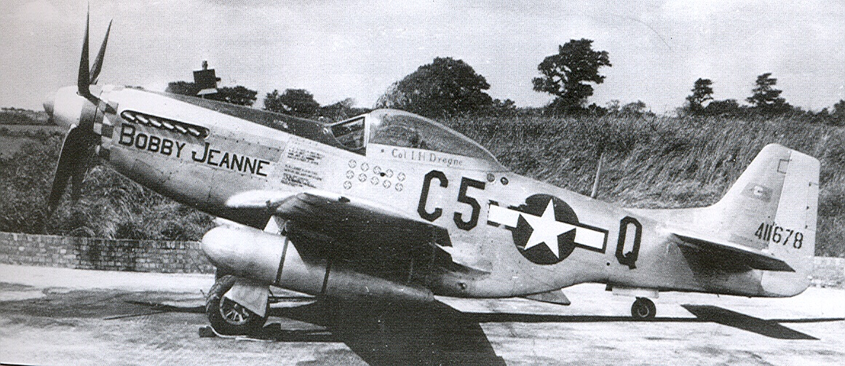
“Once december 7th came along, I decided I had one thing to do, but it was after the draft. “I got help from Robert Taft the senator from Ohio, he got me into the army, I trained for a month to be a cadet and then went Santa Anna, California for pre-flight training.” “I had never flown before, I wanted to try. Primary trianing was completed another base in California, this school taught by a world champion aironotic”. “One way they tested people was by inverting the plane and turning off the engine and telling the cadets to land the bird, it was well worth it”. “I was supposed to be a bomber pilot yet he befriended the clerks and he was able to remain a fighter pilot I flew P-40's and AT-6's. Once I got my wings I was assigned to the 357th fighter group”.

STRUGGLES IN THE AIR
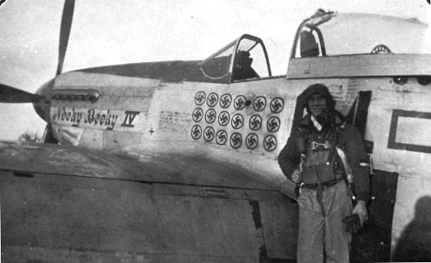
“On his first mission I lost oxygen in the air and he passed out for 90 minutes”. “I flew shuttle missions from Russia to Italy and back. In Russia I fought against the Germans, I saw a 539 russian type plane, I was told I could not fly a P-39 given to the USSR even with over 100 hours flying in one I ran into Germans in Italy as well, the Luftwaffe was retreating there was always exagerations when it came to the kill count.”
JOINING THE OSS

“I was asked to go on a secret mission, I said yeah and I was part of the OSS, I flew cover for a B-24 bomber filled with explosives into an enemy position in the mountains, John F. Kennedy's brother Joe lost his life during the mission.” “I would have direct access to the OSS now and I flew under the radar missions in Europe to landing zones set up by underground resistance. In one mission and debris hit his plane and I went down.” “I was taken prisoner by the Germans, the officer knew everything about me, stuff my highschool sweetheart would not know”. “They put me on a weapon's carrier, for transportation to a prison camp, I knocked out two enemy soldiers and escaped, I hooked up with the French underground and soon I was brought back to Engalnd.”

EIFEL TOWER INCIDENT
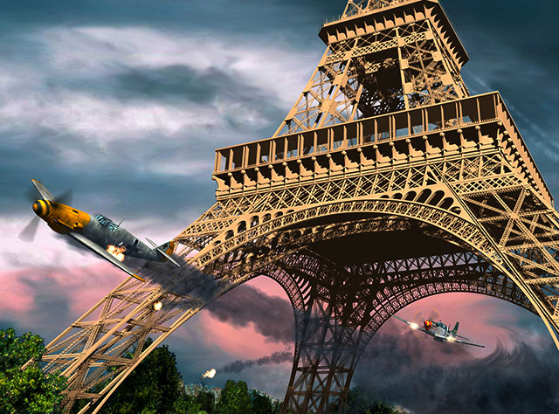
“I was escorting bombers, until we chased the Germans away we would chase them down, I fought for a while until they left me over Paris, I followed him and the enemy dicided to duck under Eifel tower, I did as well, then I shot the enemy down afterward. I have several records but I never put in a claim that I was lucky enough to be with a good team that's what counts”

HAPPY TO HAVE A TEAM
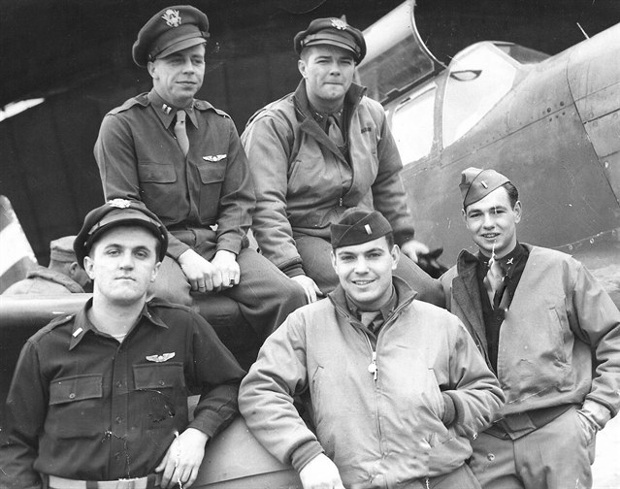
“I remember Bud Anderson and Chuck Yager, Bud was the perfect Gentlemen, Eddie Simpson was my favorate pilot. Chuck was shot down early on and went through spain he was a replacment pilot in Britian, years later Yager broke the sound barrier. Bud's son Jim has Graduated the Airforce academy.” “Everyone had each other's back on a mission, Bud never got hit, the ground crew was a part of the team, Bud made sure the planes were ready for the mission, the crew did what ever they could to prepare the planes as well”

